Local Press Contact:
Jayne Feldman
BRAVE Public Relations
404.233.3993
jfeldman@emailbrave.com

FOR IMMEDIATE RELEASE

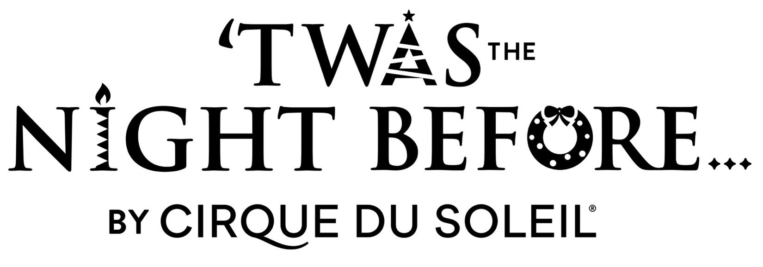

Cirque du Soleil’s First Christmas Show Makes Triumphant Premiere in Atlanta at the Fox Theatre
as Part of Regions Bank Broadway in Atlanta 2024/2025 Season
ATLANTA (Dec. 4, 2024) - The mesmerizing Cirque du Soleil show ‘Twas the Night Before…, presented by Regions Bank Broadway in Atlanta, made its Atlanta premiere last night, Dec. 3, at the Fox Theatre.
‘Twas the Night Before… is based on the classic poem “A Visit from St. Nicholas” by Clement Clarke Moore. Memorable lines from this cherished classic inspired Cirque du Soleil’s story about a jaded young girl who rediscovers the magic of the holidays. A festive flurry of love and cheer created especially for families, ‘Twas the Night Before… features thrilling acrobatics performed by a cast of 26 artists sailing from all over the world, lovable characters, and a soundtrack including holiday favorites re-invented by Cirque du Soleil.
‘Twas the Night Before… will continue its performances in Atlanta until Dec. 15. Tickets are available at the Fox Theatre box office at 660 Peachtree Street NE, by visiting foxtheatre.org/twas or by calling 855-285-8499. Group orders of 10 or more may be placed by contacting sales@foxtheatre.org.
###
About ‘Twas the Night Before… by Cirque du Soleil
‘Twas the Night Before… is Cirque du Soleil’s first Christmas show, based on the classic poem “A Visit from St. Nicholas” by Clement Clarke Moore. Memorable lines from this cherished classic inspired Cirque du Soleil’s story about a jaded young girl who rediscovers the magic of Christmas. A festive flurry of love and cheer created especially for families, ‘Twas the Night Before… features thrilling acrobatics
performed by a cast of 26 artists sailing from all over the world, lovable characters and a soundtrack including Christmas favorites re-invented by Cirque du Soleil.'Twas the Night Before… is inspired by the joy of giving and the wonder of the holiday season, with something for everyone in the family to enjoy.
For more information, visit www.cirquedusoleil.com/twas-the-night-before
Downloadable press kit, photos, trailer & b-roll:
https://media.cirquedusoleil.com/portals/bi93dsg2/TWASPRPortal
About Cirque du Soleil Entertainment Group
Cirque du Soleil Entertainment Group is a global leader in live entertainment. With over four decades of redefining the boundaries of imagination, the company brings its creative vision to a wide range of artistic forms, including live shows, multimedia productions, long-form content, music, immersive experiences, and special events. Celebrating 40 years of pushing creative limits, Cirque du Soleil has inspired more than 400 million people across 6 continents and 86 countries. The Canadian-based company now employs more than 4,000 people, including 1,200 artists from over 80 different nationalities. For more information, visit cirquedusoleil.com.
For more information about Cirque du Soleil Entertainment Group, please visit cirquedusoleil.com.
Follow #TWASCirque and #cirquedusoleil on social media: Facebook | Twitter | Instagram | YouTube
The Atlanta engagement of ‘Twas the Night Before… by Cirque du Soleil is presented by arrangement with Regions Bank Broadway in Atlanta as a part of the 2024/2025 Regions Bank Broadway in Atlanta season.
About Broadway in Atlanta
The John Gore Organization is the leading presenter, distributor, and marketer of Broadway theater worldwide. Under the leadership of 22-time Tony-winning theater producer and owner John Gore, its family of companies includes Broadway Across America, Broadway.com, The Broadway Channel, BroadwayBox.com, Group Sales Box Office and Broadway Brands. The company presents shows in 48 cities across North America as well as on Broadway, Off-Broadway, London’s West End, Japan, and China. It has won Tony Awards in every producing category as well as numerous other Drama League, Drama Desk, and Olivier Awards. The John Gore Organization is committed to supporting theater access and education programs that introduce Broadway to the next generation of audiences and theater professionals.
Broadway Across America (BAA) is part of the John Gore Organization family of companies, which includes Broadway.com, The Broadway Channel, BroadwayBox.com, Group Sales Box Office, and Broadway Brands. Led by 22-time Tony-winning theater producer John Gore (Owner & CEO), BAA is the foremost presenter of first-class touring productions in North America, operating in 48 markets with over 450,000 subscribers. Presentations include Disney’s The Lion King, Wicked, The Book of Mormon, and Hamilton. Current productions include &Juliet, Hadestown, Hamilton, Hell’s Kitchen, MJ: The Musical, Moulin Rouge! The Musical, The Outsiders and Stereophonic.

